MSU Extension’s Six-Step Community Change Model

Step 5: Make a Plan and Act

Guide: Make a Plan and Act
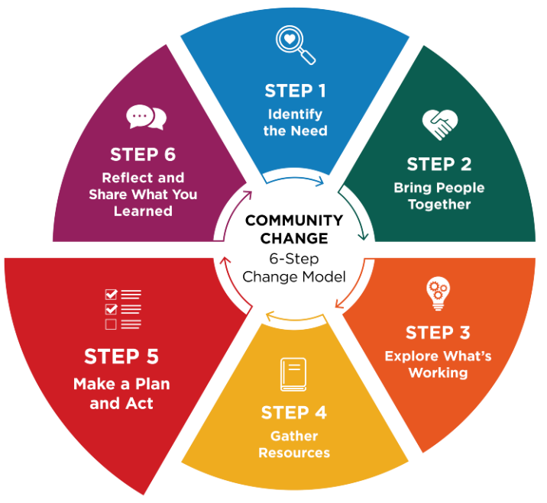
Community champions can help activate early wins and encourage participation.
Once you know what change you want to see and have decided on one clear goal, the next step is to create a plan to make it happen. An action plan turns ideas into concrete steps and is created by the people who care about the issue and can help move it forward.

Break your one clear goal into small, manageable steps
The purpose of an action plan is to make the work clear and realistic.
Each step should:
- Describe what needs to be done
- Name who is responsible
- Include a timeline
- List what is needed for success
- Identify who needs to stay informed
A strong action plan answers questions like:
- What small steps could help us reach our goal?
- What are we going to try?
- Who is responsible for each task?
- When will changes be made?
- What help or resources do we need?
- Who needs to know about the work as it moves forward?
- How will we know we succeeded or what do we need to track?
- What early “win” will get and keep the group engaged and excited for next steps?

Keep the plan flexible
An action plan is a living tool. As the work begins, the plan should be revisited and updated. Adjusting the plan helps the change team stay focused on what is working and respond early to challenges or new opportunities.
Using the action plan during regular team check-ins supports follow-through and keeps the group moving forward.
Tip: Use regular check-ins to build momentum
Check-ins help the team stay connected, motivated, and ready to adapt.
During check-ins, you can:
- Celebrate early successes
- Identify challenges or new ideas
- Adjust the plan as needed
- Discuss next steps

Identify an early win
As you shape your action plan, think about a small early success that engages your team and helps build momentum for continued progress.

Worksheet: Make a plan and act
This section helps you create an action plan by showing an example and providing an action planning template and steps to develop a clear communication plan.

action planNing worksheet
Review the example below that shows one way to develop an action plan, then use the template to create your own action plan.

Sample action plan
Example of One Clear Goal: Increase 1-2 daily physical activities by establishing regular movement breaks into the day at ABC Elementary School.
Example Early Win: Launch movement breaks with one grade level team that is ready to try it, then invite others to observe or join after the first week.

What action steps need to be taken? | Who will be responsible? | When will this be done? | What resources are needed for success?
Introduce the initiative, share activity ideas with teachers. | School wellness coordinator | Introduce the plan at the next staff meeting | - The district wellness policy  - A list or menu of simple movement activities
Choose daily movement break times. | Teachers | A week before school-wide implementation | - Menu of movement activities
Implement movement breaks school wide. Coordinator visits classrooms to support implementation. | Teachers with support from coordinator | October 1 | - Posters or cards with movements
Track participation and gather feedback from teachers and students. | Coordinator | November 15 | - Digital participation tracker and simple student survey
Review progress and adjust activities as needed. | Coordinator with school leadership | December 1 | - Results of participation and student feedback

Action planning template:

Our One Clear Goal:

What action steps need to be taken? | Who will be responsible? | When will this be done? | What resources are needed for success?

A Possible Early Win:

Communication planning
As you take action, keep communication consistent with both those involved and those who need to stay informed. Decide who needs updates, how often you will review the plan, and how you will share progress.
Who needs to know? | Frequency | How shared

Reflection
- Are there any important steps missing from the plan to make it work?
- Will the plan likely lead to the desired change?
- Connecting the dots, will the change meet your identified need?

